Further Afield: Pinal County Webb Road, Oracle AZ
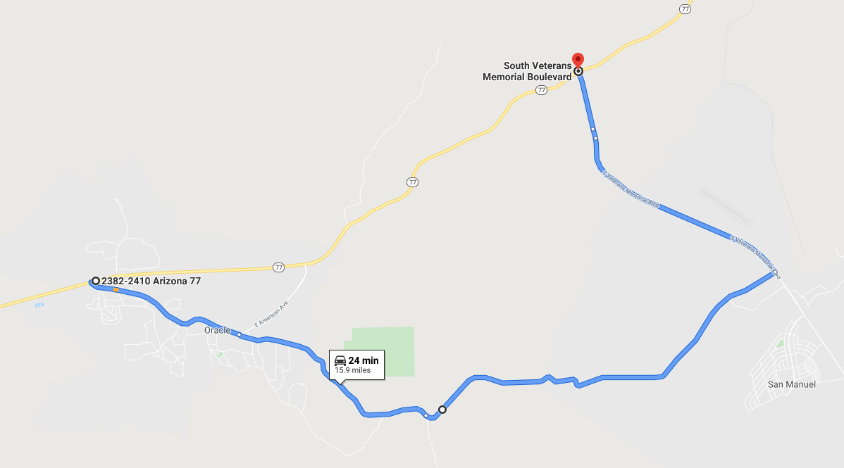

Length: 24 miles one way from State Route 77 at Oracle to State Route 77 at Mammoth

Directions: Take AZ 77 (Oracle Road) north from Tucson through Catalina to Oracle. Turn right on West American Avenue into Oracle. Follow West American Avenue through Oracle to Mount Lemmon Highway (2.3 miles). Turn right onto Mount Lemmon Highway and follow it for 3.2 miles to Webb Road. Turn left on Webb Road and follow it for 6.1 miles to South Veterans Memorial Boulevard. From here you can turn left to return to AZ77 or turn right to drive into San Manuel. If instead of turning left on Webb Road you stay on Mount Lemmon Highway for another 3.3 fun miles you’ll find yourself at the Arizona Zipline, which is another adventure.

What makes it memorable? Webb Road is a delightful little drive with many dips and turns. Along the way you’ll see lots of beautiful desert scenery. It’s so much fun that you might decide to turn around drive it again in the other direction.

Other Helpful Comments:
As you drive through Oracle you’ll pass the Patio Café on the north side of American Avenue, about 2 miles from AZ77. This is an excellent place for breakfast if you are an early person, or lunch if you aren’t. You can sit outside on the back patio. If you decide to go to the Patio Café be patient, because their kitchen is small. It’s not fast food! Another alternative for a picnic is Oracle Park (not Oracle State Park) which is at the end of Evergreen Drive directly across American Avenue from the Patio Café. It’s a cute little park with several picnic tables and some nice shade trees.
Across the street from the Patio Café is the Oracle Inn, which is a great place for a cold beer on their patio. It may be closed in summer.
Watch your speed on AZ77 between Catalina and Oracle, and on American Avenue in Oracle. The limits are low and the enforcement is sometimes strict.
