Kitt Peak

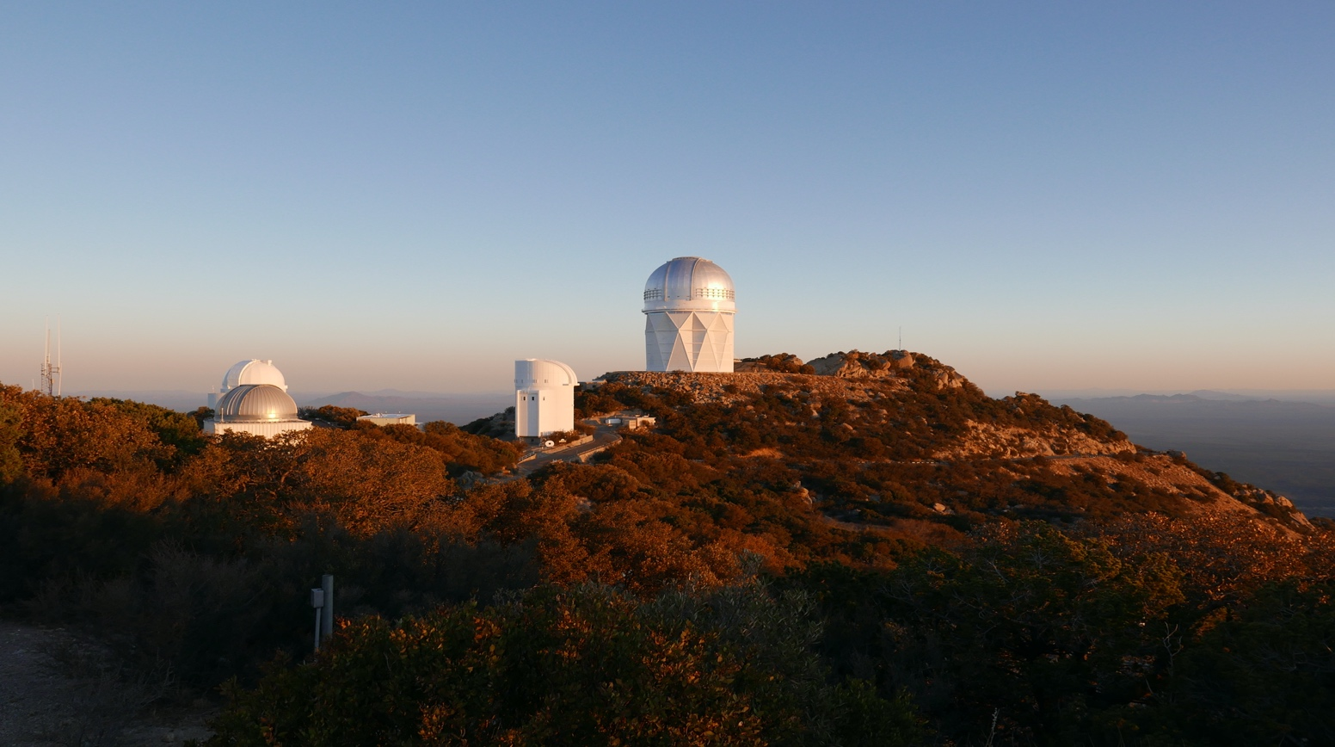

Length: 12 miles one way from the entry of State Route 386 off State Route 86.

Directions: Follow Ajo Highway west from Tucson, (State Route 86), for 37 miles to State Route 386. Turn left, (or south), and the follow the signs for 12 miles to Kitt Peak National Observatory.

What makes it memorable? The view from the observatory area in any direction is vast and awe inspiring. The lower sections of the road feature broad plains of Teddy Bear Cholla and other remarkable desert flora. At mile 8.4 a bend in the road offers incredible views to the west. Sheer rock walls frame excellent curves to test your suspension performance. The peak, at 6,875’ altitude offers a cool respite for a tree-shaded picnic.

Other Helpful Comments: If it is desired to incorporate a tour of the observatory then call Kitt Peak National Observatory, (520)-318-8726 or online noao.edu/kpno
(This field could also include suggestions on places to eat, fuel stops or lack thereof, etc.)

