Devil’s Highway, Eastern Arizona
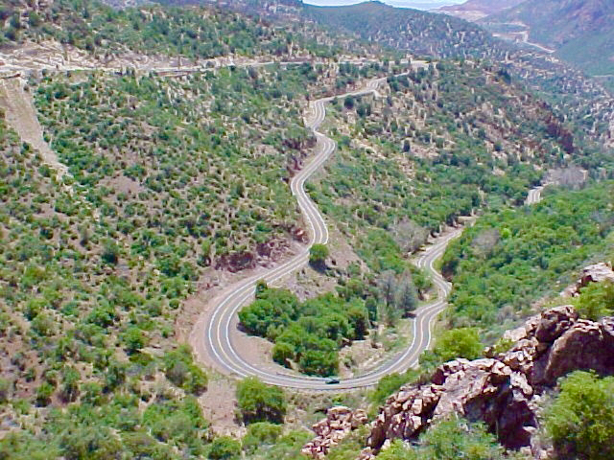

Length: Morenci to Springerville on US Highway 191; 116.7 miles one way or 2:57 non-stop one way

Directions: Morenci is 173.6 miles east of Tucson or 2:45 minutes on I-10 East to exit 352 – Highway 191 north.

What makes it memorable? Approximates the route of Coronado between 1540 and 1542. Was initially named Highway 666 as it was attached to the parent highway US 66. It is a bucket list drive of curves. There is initially a scenic view of Morenci Mine. Higher up views of the mountain ridges of SE Arizona abound. Mile 192 there is a wide grassy plateau of easy open driving; restful after the abundant curves. Before milepost 225 there is the Blue Vista overlook of the Mogollon Rim at 9,184’. Hannagan Meadows is beautiful followed by long sweeping curves around milepost 247.

Other Helpful Comments: Take care around Morenci as the mining trucks have the right of way. You must also pay attention to the fact that virtually the entire route is without shoulders. At higher elevations in forested areas watch out for elk.

Sportsman’s Lodge in Alpine is a good stop for an overnight after 90+ miles of twisties. Phone number: (877)-560-7626

